Program 1

#include<stdio.h>

int main(){
int num,arr[100],pos,i,val;
printf("Enter number of elements:\n");
scanf("%d",&num);

printf("\nEnter %d Elements:\n",num);

for(i=0;i<num;i++)
scanf("%d",&arr[i]);

printf("\nEnter position to insert element:\n");
scanf("%d",&pos);

printf("\nEnter element to be inserted:\n");
scanf("%d",&val);

for(i=num-1;i>=pos-1;i--)
arr[i+1]=arr[i];

arr[pos-1]=val;

printf("\nFinal Array: \n");
for(i=0;i<=num;i++)
printf("%d ",arr[i]);

printf("\n\n");
}
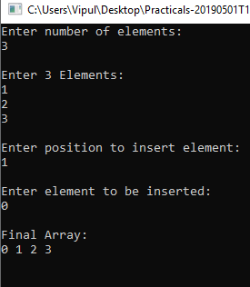
Program 2

#include<stdio.h>

int main(){
int num,arr[100],i,val;
printf("Enter number of elements:\n");
scanf("%d",&num);

printf("\nEnter %d Elements:\n",num);

for(i=0;i<num;i++)
scanf("%d",&arr[i]);

printf("\nEnter element to be inserted at the beginning:\n");
scanf("%d",&val);

for(i=num-1;i>=0;i--)
arr[i+1]=arr[i];

arr[0]=val;

printf("\nFinal Array: \n");
for(i=0;i<=num;i++)
printf("%d ",arr[i]);

printf("\n\n");
}

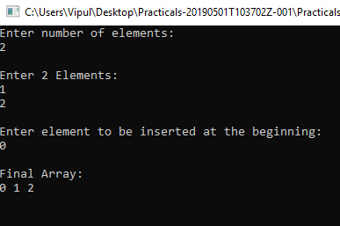
Program 3

#include<stdio.h>

int main(){
int num,arr[100],i,val;
printf("Enter number of elements:\n");
scanf("%d",&num);

printf("\nEnter %d Elements:\n",num);

for(i=0;i<num;i++)
scanf("%d",&arr[i]);

printf("\nEnter element to be inserted at the end:\n");
scanf("%d",&val);

arr[num]=val;

printf("\nFinal Array: \n");
for(i=0;i<=num;i++)
printf("%d ",arr[i]);

printf("\n\n");
}

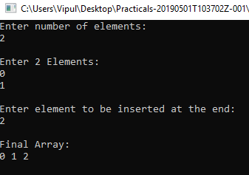
Program 4

#include<stdio.h>
int main(){
int arr[25],n,val,i;
printf("Enter number of elements:\n");
scanf("%d",&n);
printf("\nEnter %d Elements:\n",n);
for(i=0;i<n;i++)
scanf("%d",&arr[i]);
printf("\nEnter element to be searched: ");
scanf("%d",&val);
for(i=0;i<n;i++){
if(val==arr[i]){
printf("\nElement Position = %d",i+1);
break; }
}

}

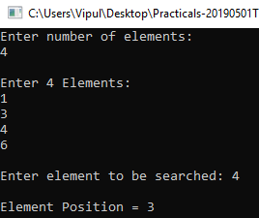
Program 5

#include <stdio.h>
int main()
{
int arr[100], position, c, n;

printf("Enter number of elements in array: ");
scanf("%d", &n);

printf("\nEnter %d elements:\n", n);

for (c = 0; c < n; c++)
scanf("%d", &arr[c]);

printf("\nEnter the location where you wish to delete element: ");
scanf("%d", &position);

if (position >= n+1)
printf("\nDeletion not possible.\n");
else
{
for (c = position - 1; c < n - 1; c++)
arr[c] = arr[c+1];

printf("\nResultant array:\n");

for (c = 0; c < n - 1; c++)
printf("%d\n", arr[c]);
}
}

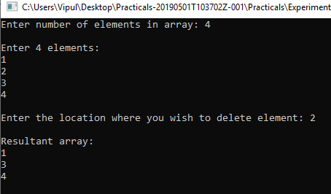
Program 6

#include <stdio.h>
int main()
{
int arr[100], c, n;

printf("Enter number of elements in array: ");
scanf("%d", &n);

printf("\nEnter %d elements:\n", n);

for (c = 0; c < n; c++)
scanf("%d", &arr[c]);

for (c = 0; c < n - 1; c++)
arr[c] = arr[c+1];

printf("\nResultant array:\n");

for (c = 0; c < n - 1; c++)
printf("%d\n", arr[c]);
}

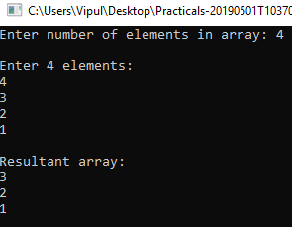
Program 7

#include <stdio.h>
int main()
{
int arr[100], c, n, max, min;

printf("Enter number of elements in array: ");
scanf("%d", &n);

printf("\nEnter %d elements:\n", n);

for (c = 0; c < n; c++)
scanf("%d", &arr[c]);

max=arr[0];
min=arr[0];
for (c = 0; c < n; c++){
if(arr[i]>max)
max=arr[i];
if(arr[i]<min)
min=arr[i];
}

printf("\nLargest Element = %d\nSmallest Element = %d\n",max,min)

}

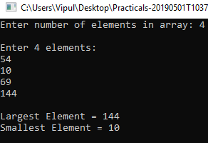
Program 8

#include <stdio.h>
int main()
{
int arr[100], c, n;

printf("Enter number of elements in array: ");
scanf("%d", &n);

printf("\nEnter %d elements:\n", n);
for (c = 0; c < n; c++)
scanf("%d", &arr[c]);

printf("\nResultant array of Even Elements:\n");
for (c = 0; c < n ; c++)
if(arr[c]%2==0)
printf("%d\n", arr[c]);
}

